**Project Documentation**

Project Title

# 1. Introduction

* **Project Title:** COOKBOOK
* **Team ID**: NM2025TMID29990
* **Team Leader:**

S.Smitha – 202400093@sigc.edu

* **Team Members:**

B.Manjusree – 202400226@sigc.edu

S.Mithra – 202400070@sigc.edu

A.Naazhini – 202400894@sigc.edu

# 2. Project Overview

* **Purpose:** The purpose of this project is to create an interactive and user-friendly recipe website where users can discover new dishes, explore categories, and learn cooking through clear instructions and engaging visuals**.**.
* **Features:**
  + Homepage with recipe highlights and search functionality.
  + Recipe detail pages with ingredients, steps, and images.
  + Embedded video tutorials for better learning.
  + Category-wise recipe browsing (Dessert, Chicken, Vegan, etc.).
  + Subscription option for exclusive recipes and cooking tips.

# 3. Architecture

* **Frontend:** HTML for structure ,CSS for styling, JavaScript for embedding.
* **Backend:** This is a frontend-based project without backend integration.
* **Database:** MongoDB stores recipes , users , subscriptions.

# 4. Setup Instructions

* **Prerequisites:**
  + Node.js
  + MongoDB
  + Git
  + React.js
  + Express.js **–** Mongoose **–** Visual Studio Code
* **Installation Steps:**

# Clone the repository git clone

# Install client dependencies cd client npm install

# Install server dependencies cd

../server npm install

# 5. Folder Structure

Tasty-Bites/

│

├── node_modules/ → Project dependencies (auto-generated)

│

├── public/ → Public assets (accessible directly)

│ ├── favicon.ico

│ ├── index.html → Main HTML template

│ ├── logo192.png

│ ├── logo512.png

│ ├── manifest.json

│ └── robots.txt

│

├── src/ → Main source code

│ ├── components/ → Reusable UI components

│ │ ├── About.jsx

│ │ ├── CategoriesHome.jsx

│ │ ├── Footer.jsx

│ │ ├── Hero.jsx

│ │ ├── Navbar.jsx

│ │ └── NewsLetter.jsx

│ │

│ ├── images/ → Project images (recipes, banners, etc.)

│ │

│ ├── pages/ → Full page components

│ │ ├── CategoryPage.jsx

│ │ └── Recipe.jsx

│ │

│ ├── styles/ → CSS files for styling

│ │ ├── About.css

│ │ ├── CategoriesHome.css

│ │ ├── CategoryPage.css

│ │ ├── Footer.css

│ │ ├── Hero.css

│ │ ├── Home.css

│ │ ├── Navbar.css

│ │ ├── NewsLetter.css

│ │ └── Recipe.css

│ │

│ ├── App.css → Global styles

│ ├── App.js → Root React component

│ ├── App.test.js → Test file

│ ├── index.css → Entry CSS file

│ ├── index.js → Entry point for React DOM rendering

│ ├── logo.svg

│ ├── reportWebVitals.js → Performance reporting

│ └── setupTests.js → Testing setup

│

├── .gitignore → Files ignored by Git

├── package-lock.json → Dependency lock file

├── package.json → Project metadata & dependencies

└── README.md → Project documentation

# 6. Running the Application

* **Frontend:**

cd code npm

start

• **Backend:**

cd server npm start

* **Access:** Visit http://localhost:3000

# 7. API Documentation

* **User:**
  + /api/user/subscribe
* **Receipes:**
  + /api/receipes/open
  + /api/projects/:id

• **Category:**

* /api/category/:category
* **Search:**
  + /api/recipes/search? Query=keyword

# 8. Authentication

* JWT-based authentication for secure subscription
* Middleware protects private routes

# 9. User Interface

* Home Page
* Categories Page
* Subscribe Section
* Footer

# 10. Testing

* Manual testing during milestones
* Navigation bar
* Tools: Postman, Chrome Dev Tools

1. **Screenshots or Demo**

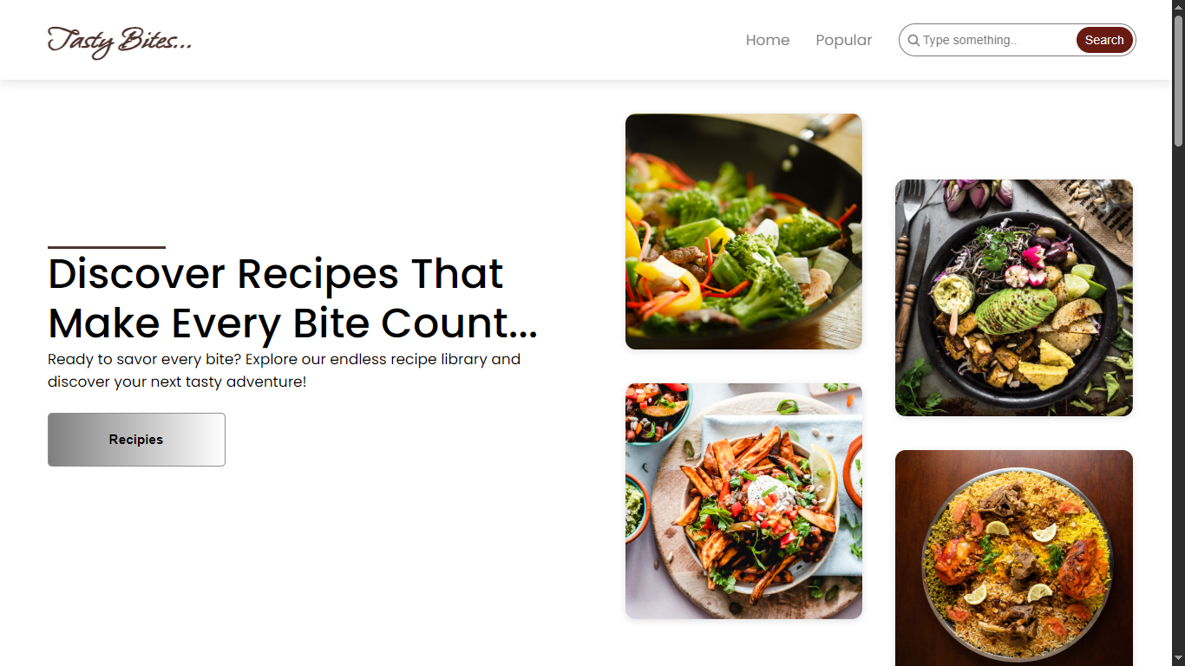

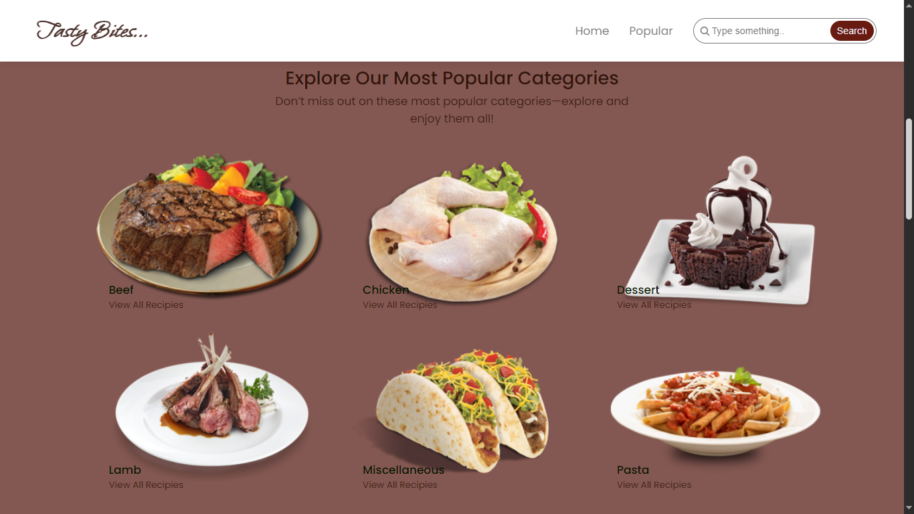

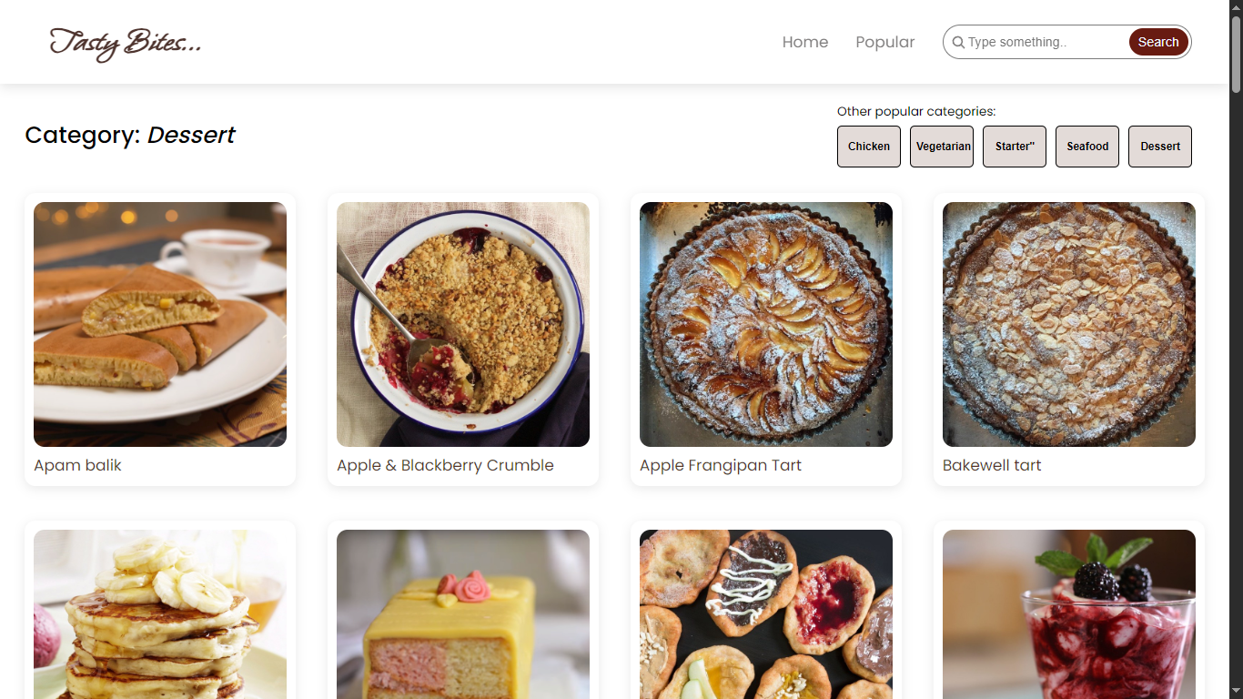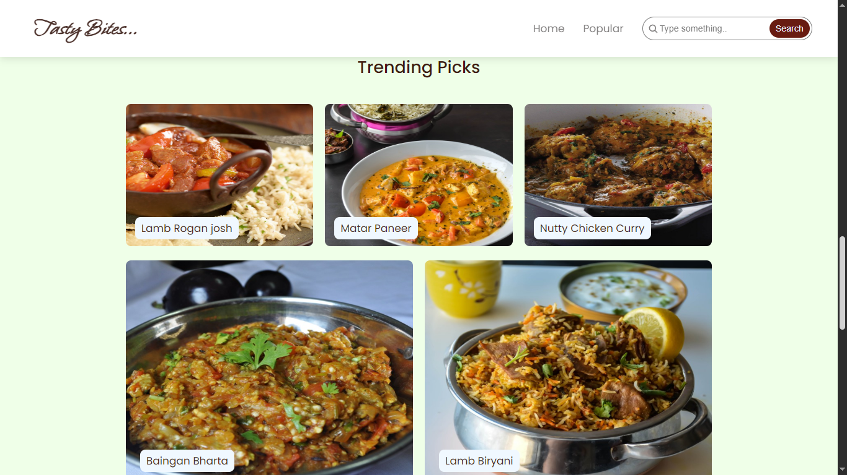

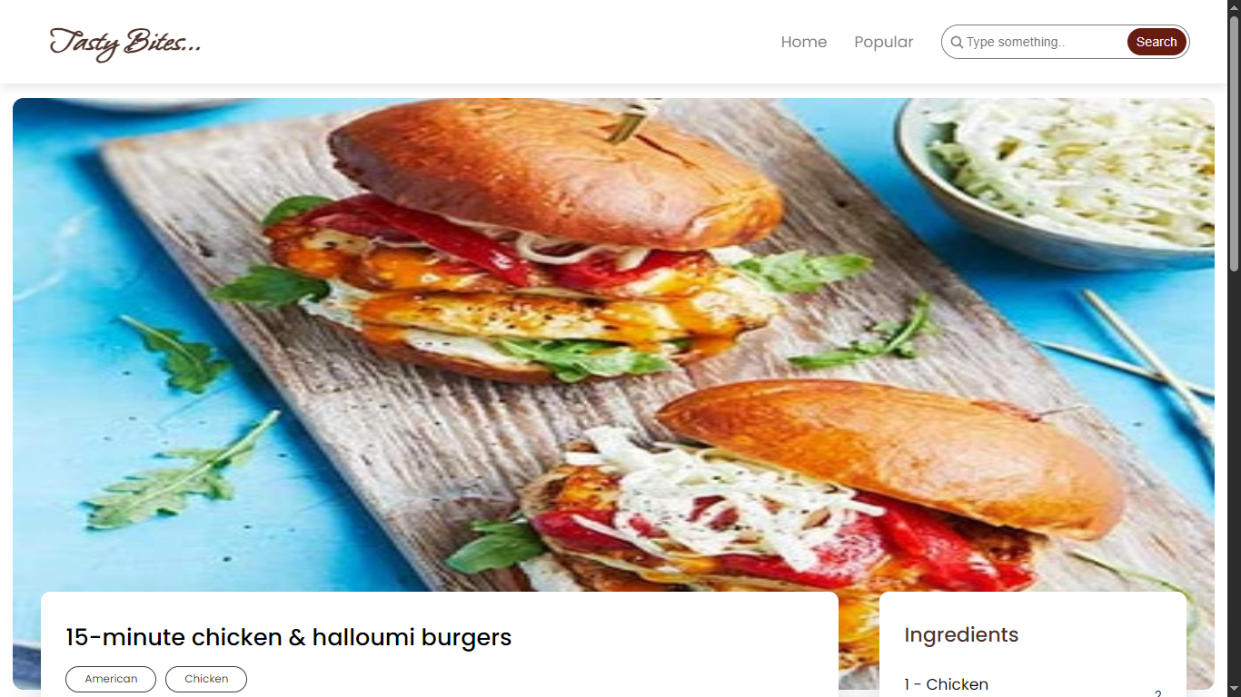

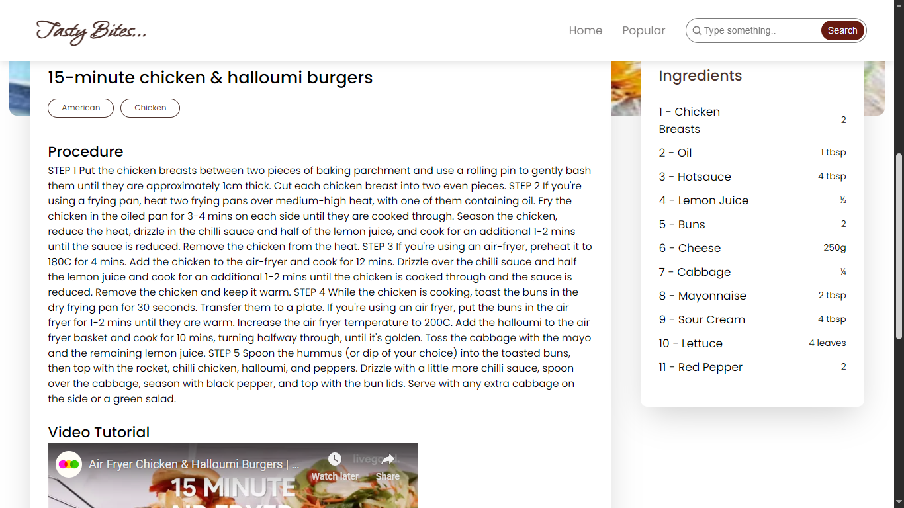

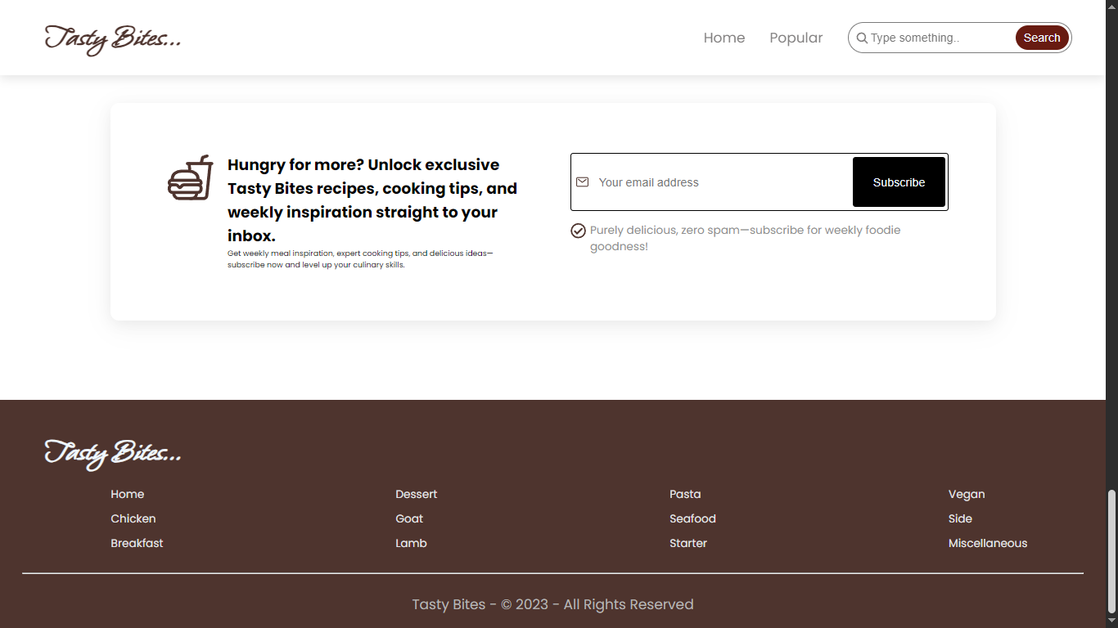

**Video link:**

[**https://drive.google.com/file/d/1iRdOtEjnQDNOAsHkNcr3vzL8aiRWma0e/view?usp=drive_link**](https://drive.google.com/file/d/1iRdOtEjnQDNOAsHkNcr3vzL8aiRWma0e/view?usp=drive_link)

**12. Known Issues**

* No backend integration
* Limited data

# 13. Future Enhancements

* AI powered suggestions
* Rating and Review systems
* User interactions.